

ISLAMIC UNIVERSITY OF TECHNOLOGY (IUT)

ORGANISATION OF ISLAMIC COOPERATION (OIC)
Department of Computer Science and Engineering (CSE)

Project Proposal
CSE 4206 : Digital Logic Design Lab

Team Members

Nusrat Zahan Nishi (240042145)
Tahmid Wasif (240042143)
Mumtahina Marium (240042110)
Amina Rahman Shalu (240042101)
Mahdia Hossain (240042109)
Rakibul Hasan (240042108)

MIDNIGHT MUSEUM
THE CURSED ARTIFACT HUNT

Motivation
Museums are designed to preserve priceless artifacts that represent history and culture. Protecting these valuable collections requires constant monitoring, quick decision-making, and reliable security systems. But what if some artifacts were cursed? Inspired by mystery and puzzle games, we aim to build an interactive digital system where the player acts as the night curator of a haunted museum. The project combines digital logic concepts with a game-based environment, allowing us to implement and understand combinational and sequential circuits in a practical and engaging way.

Description
The museum enters Security Mode every night after closing hours. During each round, the system generates a mysterious artifact at a random location inside an 8×8 museum grid. The player controls a movable cursor using directional buttons and must locate and secure the artifact before the countdown timer expires.
Artifacts are classified into three categories:
- Blessed Artifact – Successfully securing it awards 1 point.
- Golden Artifact – Successfully securing it awards 3 points.
- Cursed Artifact – Attempting to secure it reduces one life, representing a dangerous or trapped artifact.
As the player's score increases, the system automatically increases the difficulty by reducing the available response time for each new artifact. This creates progressively more challenging gameplay while demonstrating adaptive digital logic.
The game continues until either all lives are lost or the countdown timer expires with no remaining lives, at which point the system enters the Game Over state.

Mechanism:
The museum security system operates in the following sequence:
1. System Initialization
When the player presses the Start button, the system initializes all game variables. The cursor is placed at its default position, the score is reset to zero, the player is assigned three lives, and the countdown timer begins.

2. Cursor Movement
The player controls the security cursor using four directional push buttons (Up, Down, Left, Right). The Priority Encoder ensures that if multiple buttons are pressed simultaneously, only one movement command is executed according to the predefined priority. The updated cursor coordinates are stored inside registers and continuously displayed on the LED matrix.
3. Artifact Generation
For every round, the Artifact Generator produces a pseudo-random artifact position using an LFSR (Linear Feedback Shift Register).The system also randomly determines the artifact type:
- Blessed Artifact
- Golden Artifact
- Cursed Artifact
Before placing the artifact, a comparator checks whether the generated position coincides with the player's current cursor position. If both positions are identical, another location is generated to ensure fair gameplay.Only one artifact exists inside the museum at any time.

4. Artifact Detection and Capture
As the player moves around the museum, the Comparator continuously compares the cursor coordinates with the artifact coordinates.When the player presses the Seal button:
- If the cursor matches a Blessed Artifact, the player gains 1 point.
- If the cursor matches a Golden Artifact, the player gains 3 points.
- If the cursor matches a Cursed Artifact, one life is deducted.
- If no artifact exists at the selected location, the system ignores the action and gameplay continues.
After every successful capture, a new artifact is generated automatically.

5. Timer System
Each artifact must be captured before the countdown timer reaches zero.The timer is generated using a 555 Timer and counted using a Synchronous Counter.Whenever an artifact is successfully captured, the timer automatically resets for the next round.If the timer expires before the artifact is captured, one life is deducted and a new artifact is generated.

6. Score System
The player's score is updated according to the artifact type.
- Blessed Artifact → +1
- Golden Artifact → +3
- A BCD Adder calculates the updated score, while a BCD Decoder drives the Seven-Segment Display to show the current score.

7. Life System
The player begins the game with three lives. Lives decrease when:
- A cursed artifact is captured.
- The countdown timer expires before the artifact is sealed.
A Comparator continuously checks whether the life counter has reached zero.Once all lives are lost, the Game Logic Controller immediately transfers the system into the Game Over state.

8. Difficulty Controller
To make gameplay progressively more challenging, the Difficulty Controller monitors the player's score.Whenever predefined score thresholds are reached, the system decreases the countdown duration for future rounds.For example:
- Score 0–5 → 15 seconds
- Score 6–10 → 12 seconds
- Score 11–15 → 9 seconds
This feature demonstrates adaptive sequential logic using counters, comparators, and multiplexers.

9. Display Controller
The Display Controller continuously updates all visual outputs. The 8×8 LED Matrix displays
- Museum grid
- Security cursor
- Current artifact location
- Different blink patterns for artifact types
The Seven-Segment Displays show
- Current Score
- Remaining Time
Additional LEDs indicate
- Remaining Lives
- Game Over
- Alarm Status

Components of the project

Inputs

Push Buttons
- Move Up
- Move Down
- Move Left
- Move Right
- Seal Artifact
- Start Game
- Reset Game

Adder Subtractor

BCD Adder
- Updates player's score
- Adds +1 or +3 after successful artifact capture

Encoder Decoders

Priority Encoder
- Resolves simultaneous movement button presses

Decoder
- Drives the LED Matrix display

Multiplexer
- Routes cursor position, artifact position, and timer signals to the appropriate modules

Comparator

Magnitude Comparator
- Compares cursor position with artifact position
- Detects successful artifact capture
- Detects Game Over condition
- Controls difficulty level changes

Flip-Flops

D Flip-Flops
- Synchronize player inputs
- Store game state transitions
- Stabilize cursor movement

Registers
1. Parallel-In Parallel-Out Registers (PIPO)
- Store cursor coordinates.
- Store artifact coordinates.
- Store current game state.
2. Linear Feedback Shift Register (LFSR)
- Generates pseudo-random artifact positions.
- Generates artifact types (Blessed, Golden, or Cursed).

Counters

Up/Down Counter
- Controls cursor movement

Synchronous Counter
- Countdown timer
- Tracks remaining lives

BCD Up Counter or Decade Counter
- Keeps track of player's score
- Tracks remaining lives
- Monitors score thresholds

Outputs

8×8 LED Matrix Displays
- Museum layout
- Cursor
- Artifact

Seven-Segment Display Displays
- Score
- Remaining Time

LEDs Indicate
- Remaining Lives
- Alarm Status
- Game Over

Project Diagram

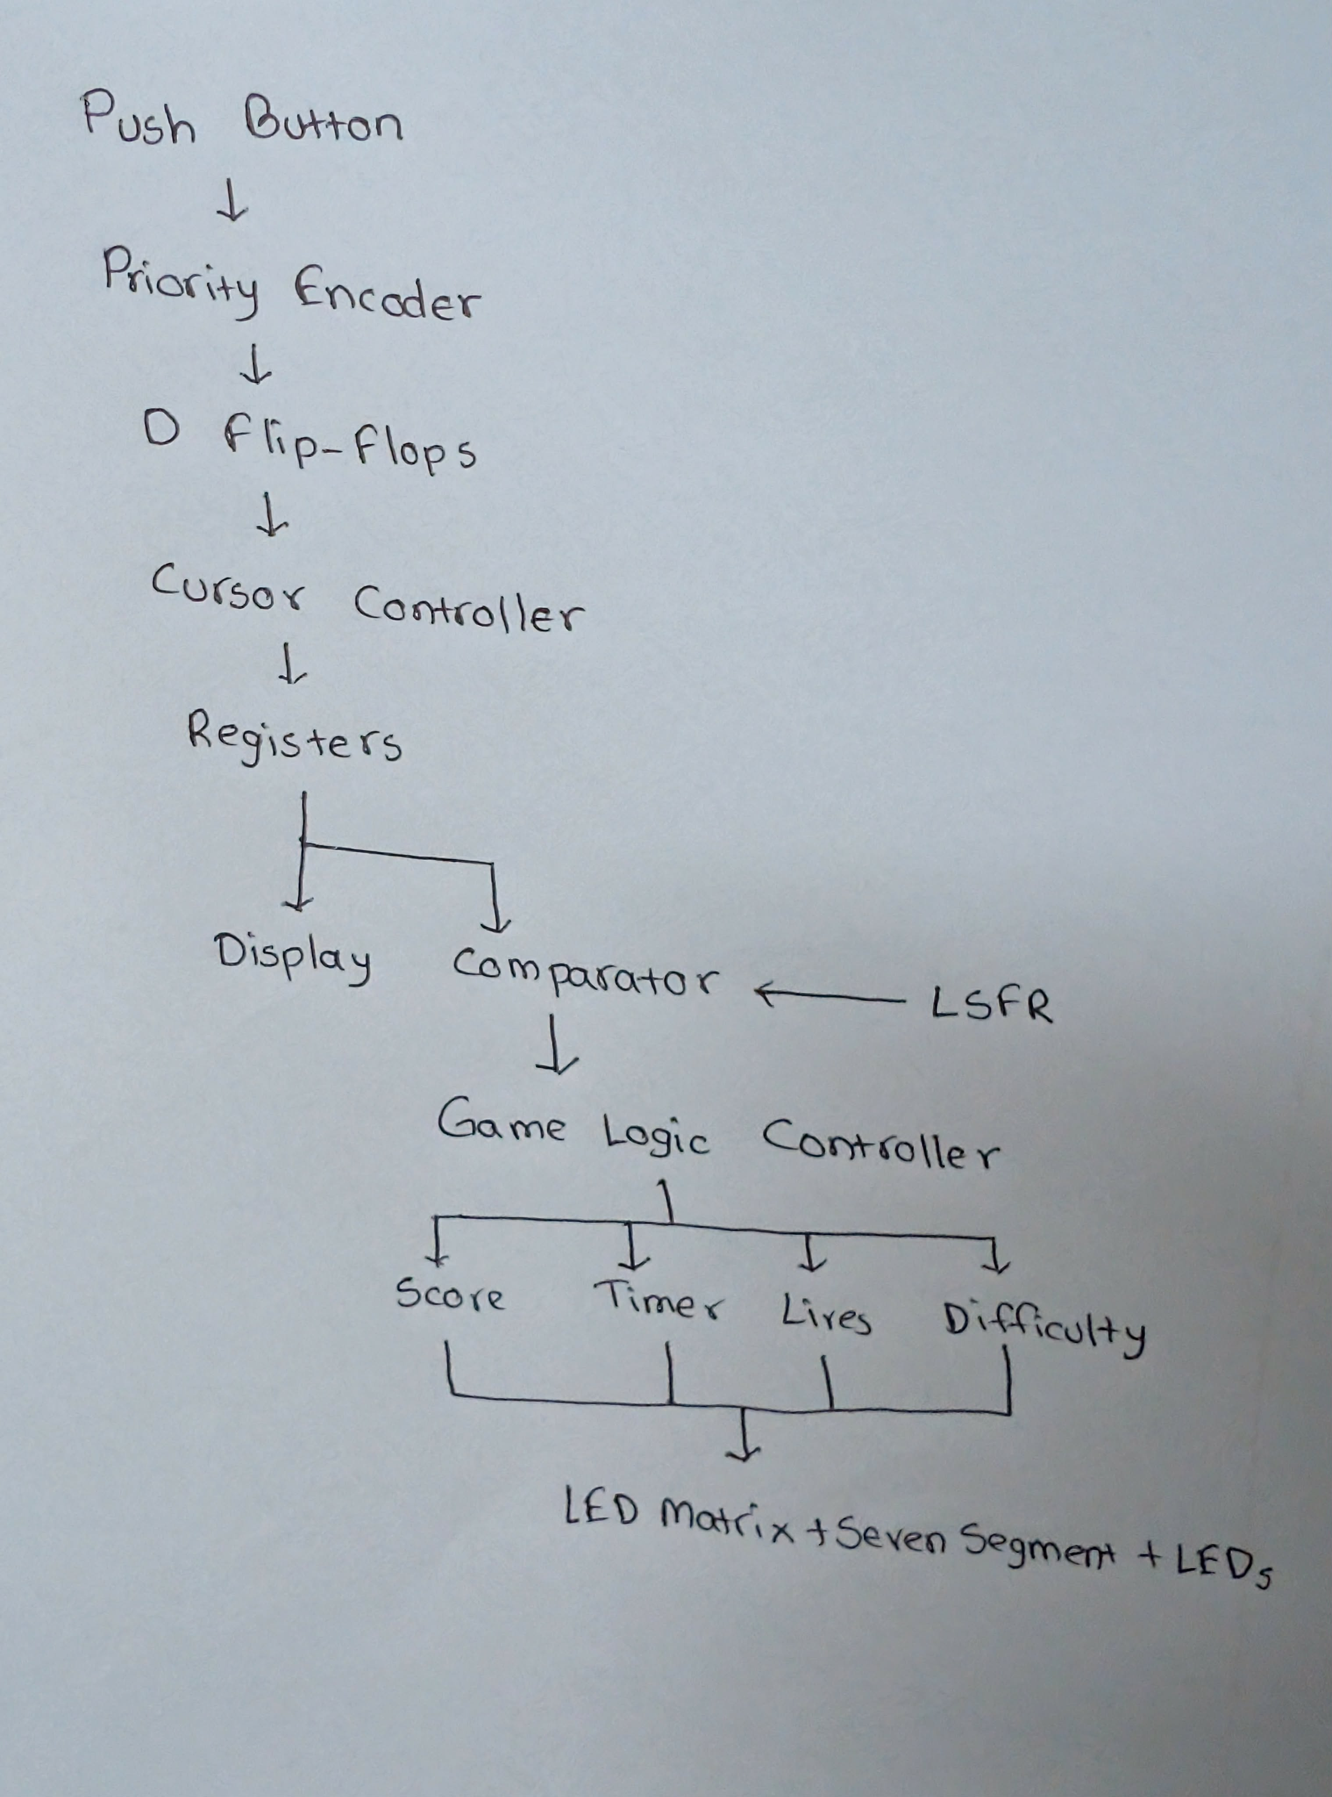
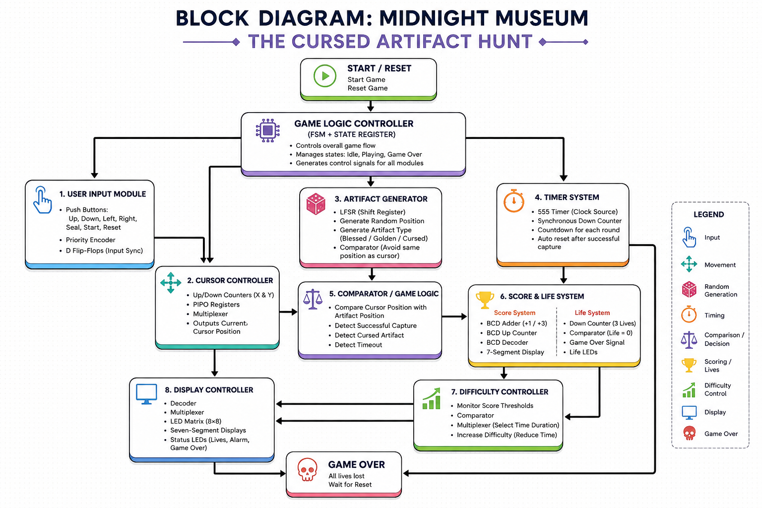

Edge Cases
- If the randomly generated artifact appears at the player's current cursor position, the Comparator requests another random position until a valid location is generated.
- Only one artifact may exist inside the museum at any time.
- If multiple directional buttons are pressed simultaneously, the Priority Encoder determines which movement command has the highest priority.
- Pressing the Seal button when no artifact is present at the selected location has no effect.
- The countdown timer automatically resets whenever an artifact is successfully captured.
- If the timer expires before an artifact is captured, one life is deducted and a new artifact is generated automatically.
- The player's life counter never decreases below zero.
- After reaching the Game Over state, all gameplay inputs are ignored until the Reset button is pressed.
- Difficulty increases only after reaching predefined score thresholds.
- Pressing the Reset button immediately clears the score, timer, lives, cursor position, and artifact position, returning the system to its initial state.

Feedback
(To be provided by course teacher)

